EzUI_Simulate interface
debugging tool
User's manual
V22 – 2015.03



Hotdisplay Technology Co.Ltd Technical Information

Copyright notice
Hotdisplay Technology Co.Ltd reserves the right to modify this document without prior notice. The information provided by Hotdisplay Technology Co.Ltd is believed to be accurate and reliable, but it does not guarantee that there are no errors in this document. Please ensure that the relevant technical documents and product specifications you use are up-to-date before placing an order with Hotdisplay Technology Co.Ltd. If your company uses our documents or products, which may involve the application of third-party patents or copyrights and other intellectual property rights, you are responsible for obtaining the necessary consent and authorization. The company does not guarantee such consent and authorization.

Catalog
Copyright notice 2
1 Tool introduction 4
1.1 EzUI_Simulate tool introduction 4
1.2 EzUI_Simlate working mode 4
2 EzUI_Simulate software interface 6
2.1 User operation area 8
2.1.1 "Download resources" page 8
2.1.2 Control button and number button tabs 10
2.1.3 The "Controls Settings" TAB 10
2.1.4 Communication data observation column 10
3 Debugging in software simulation mode 12
3.1 Interface debugging in software simulation mode 12
3.2 User MCU participates in simulation debugging 13
3.3 matters need attention 15
4 Online joint debugging mode (USB port joint debugging) 16
4.1 Install the USB driver 16
4.2 Debugging without opening the module port 18
4.3 In addition to the above operations, many examples of button operations cannot be presented one by one. Users can use tool software for relevant testing and verification. 25
4.4 USB port synchronization and debugging 29
5 Online joint debugging mode (UART interface joint debugging) 30
5.1 matters need attention 30
6 technical support 31
6.1 contact way 31

Tool introduction

EzUI_Simulate tool introduction
EzUI_Simulate is a tool software designed for the EzUI series (including the EzUILet series) modules, used for interface debugging, module simulation, and resource file downloading. Users can use this tool to replace the EzUI series (including the EzUILet series) modules for interface debugging and module simulation, achieving development without hardware. Additionally, users can also use this tool to burn resources onto the EzUILet series modules.

EzUI_Simlate working mode
The V22 version of EzUI_Simulate tool supports three working modes, as follows:
Software Simulation Mode: In this mode, after the EzUI_Simulate tool opens a resource file, it simulates an EzUI display module on the computer. Users can perform touch operations and view the execution results (limited to EzUI modules with touchscreens). If users use the software to open a serial port on the computer, the tool will utilize the computer's serial port to simulate the UART interface of the EzUI module. This allows the tool to receive commands and data from the user's microcontroller via the serial port, and also send messages from the EzUI GUI service engine through the serial port.
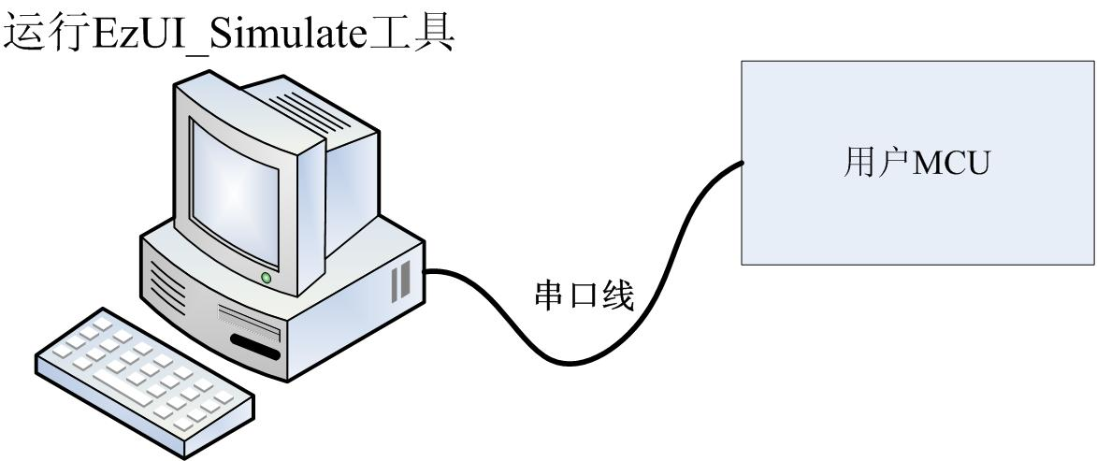
Online Debugging Mode (USB Port Debugging): This mode supports only the modules in the EzUI series that have USB debugging capabilities. Modules with USB debugging capabilities can create a virtual serial port on a computer. Users need to open this serial port in the tool software and then use the tool software to burn the opened resource files into the module (this is available for EzUILet series modules, while for large-resource-mode EzUI series modules, it involves copying from a module U disk). Synchronization debugging can then be performed with the module. For parts of the EzUI module that do not support touch, the tool can simulate some key messages sent by the user MCU.
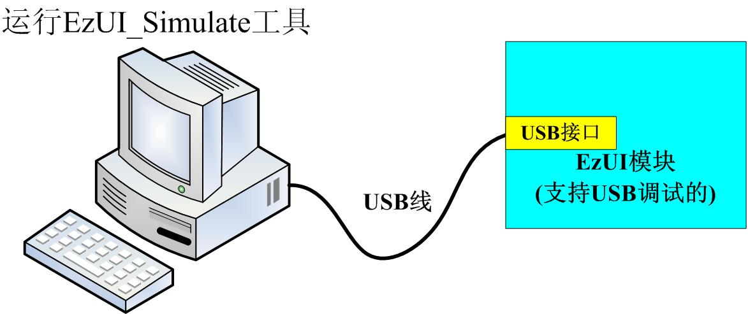
Online joint debugging mode (UART interface joint debugging): In this mode, the tool will use the serial port of the computer to connect with the UART interface of the EzUI module to realize the synchronous debugging between the tool software and the EzUI module; for the part of the EzUI module that does not support touch, the tool can simulate some key messages sent by the user MCU.
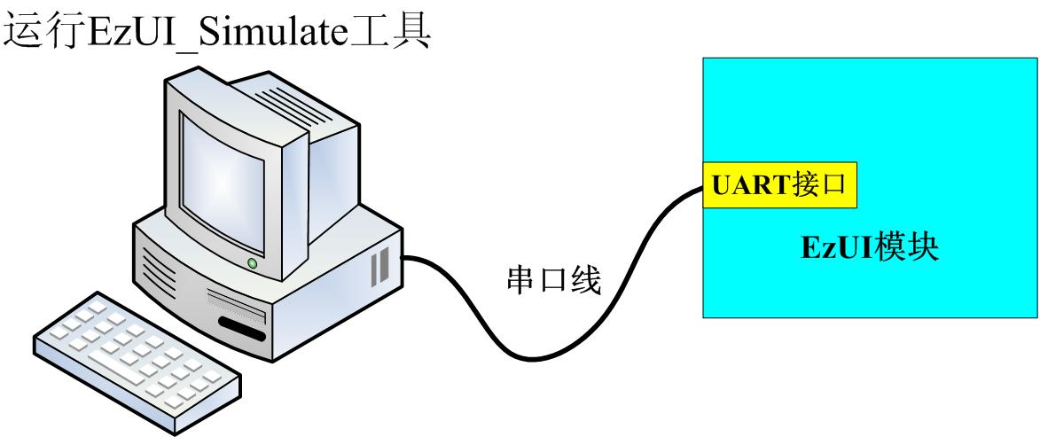

Note: The UART serial port of EzUI series modules is mostly TTL level, while the serial port on the computer is RS232 level. When using the serial port line to connect the module with the computer, it should be noted that the RS232 level must be converted to TTL level.

EzUI_Simulate software interface
Double-click "EzUI_SimulateV22.exe" to open the main interface of the tool software, as shown in the following figure:
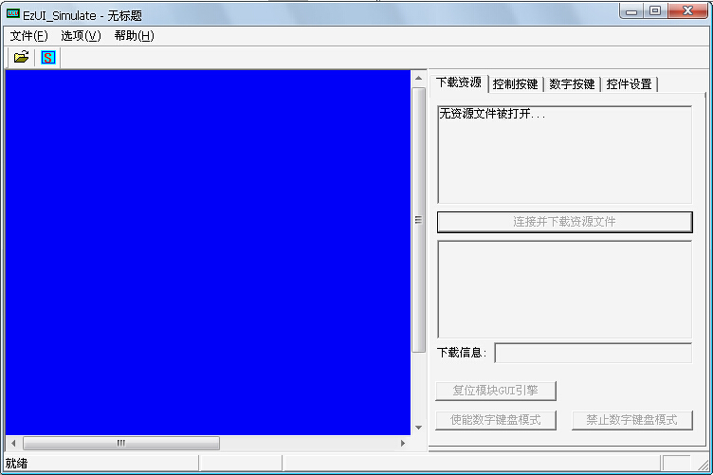
Since no resource file is opened, the display area of the interface is displayed with a blue background. Click the "" tool button in the toolbar to open the communication data observation bar. At this time, the entire interface block of the tool will be presented. The main work of the tool software includes the following major areas:
- primary menu;
- tool bar;
- Simulated screen display area: This area will simulate the display screen of EzUI module. For EzUI module with touch, in software simulation mode, the mouse can be used to simulate touch operation in this area;
- User Operation Area: This area contains multiple pages. The first three pages are only valid for touchless EzUI modules. When the tool is in online joint debugging mode, you can simulate sending key messages or other control messages from the user MCU to the EzUI module on these three pages. Notably, the "Connect and Download Resources" button on the first page is available only for EzUILet series modules. The last page is dedicated to writing and reading resource controls;
- Communication data observation column: This column will display the data packets sent by the user to the module through the serial port, as well as the data returned by the GUI service engine when the EzUI module occurs.
The main interface of the tool is shown in the following figure:

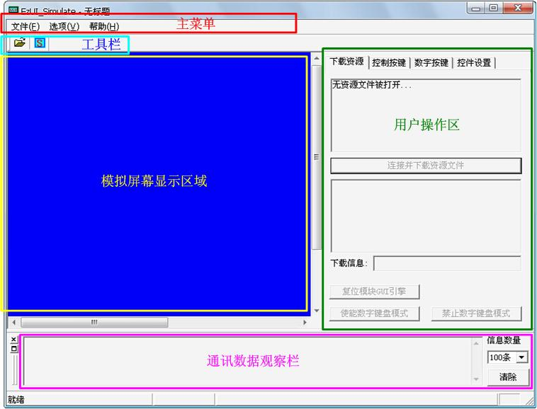

User operation area
There are four tabs in the user operation area, as shown in the following four pictures:
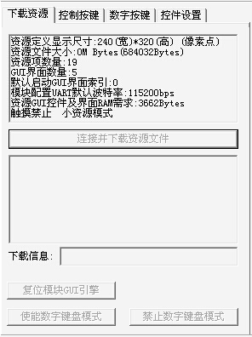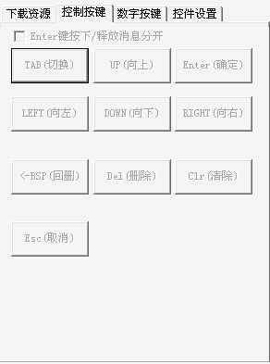
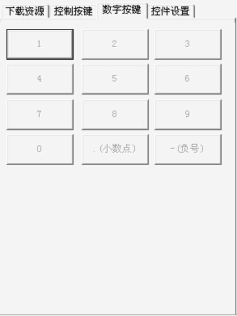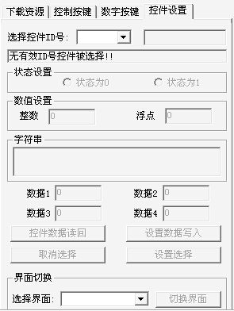

"Download resources" page
The "Download Resource" page displays the basic information of the resource file currently open, as shown in the following figure:
In the displayed information, there is one item that requires user attention: "Resource GUI Controls and Interface RAM Requirements." This information shows the byte count required for the dynamic RAM area of the module based on the resource file currently open, specifically for EzUILet series modules (i.e., a streamlined version of the EzUI series). When using EzUILet series modules, it is necessary to check the module's data manual to ensure that this data does not exceed the dynamic RAM area size provided by the module. If it exceeds, the module will not function properly.
In addition, for the EzUILet series module, the resource file will configure the UART baud rate after the module loads the resource file, but this data setting does not affect the use of EzUI_Simulate tool, and the tool software will work according to the actual computer serial port baud rate opened.
The function of the "Connect and Download Resource File" button in the "Download resource" page is only useful for EzUILet modules. The two information output columns below the button show the actual configuration of the module and the download progress when using USB port to connect and download resource files to the module, as shown in the following figure:
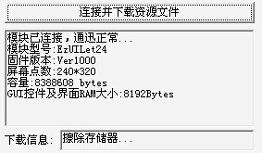
The information bar below the "Connect and Download Resource Files" button will display module information when you click this button after connecting the tool software with the module; you can see the module's resource memory capacity (8M Bytes in the legend), GUI controls, and interface RAM size (i.e., dynamic RAM area size, 8K Bytes in the legend).
Note: The "Connect and Download Resource File" button is only valid when the tool software is in "Online joint debugging mode" and the module USB joint debugging mode is used, and the EzUI module is required to support USB joint debugging.
"Reset module GUI engine": This button will simulate the user MCU to send instructions to EzUI module to control the GUI service engine of EzUI module, so that the interface and controls can restore the display and state of the module when it is powered on (Note: some EzUI module versions are older and do not support this instruction);
"Enable digital keyboard mode": This button will simulate the user MCU sending commands to the EzUI module, which is only valid for the EzUI module without touch;
"Disable digital keyboard mode": This button will simulate the user MCU to send instructions to the EzUI module, which is only valid for the EzUI module without touch;

Control button and number button tabs
The "Control button" and "Digital button" tabs are only valid for the touchless EzUI module, and the buttons in these two tabs will simulate the user MCU sending commands to the EzUI module.

The "Controls Settings" TAB
There are two main contents in the "Control Settings" tab, one is control operation, the other is interface switching, as shown in the following figure:
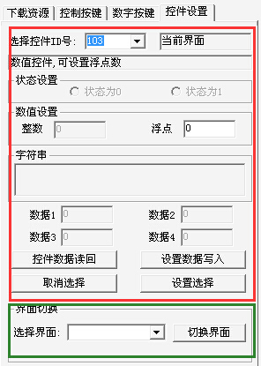
The area within the red box in the image above is where you can perform operations related to "Control Settings." At the top left is a drop-down menu from which you can select controls defined in the open resource files. To the right of this menu, it will show whether the control is currently present on the current interface. Below, different numerical displays and setting interfaces are provided based on the type of control.
"Control data read back": This button simulates the user MCU sending a command to the EzUI module to read the control data.
"Set data write in": This button can simulate the user MCU to send control value write in command to EzUI module, so as to write the control value/state set by the user on this page into EzUI module.
"Cancel selection": This button is only valid for the touchless version of EzUI module. It can simulate the user MCU sending control selection instructions to EzUI module to achieve the effect of canceling the current control selection.
"Set Selection": This button is only valid for the touchless version of the EzUI module and can simulate the user MCU sending control selection instructions to the EzUI module.

Communication data observation column
This column can display the communication data triggered by the user MCU button message simulated on the EzUI module (including the EzUI_Simulate tool simulation and the actual EzUI module connected to the tool through the serial cable) and the user MCU, as shown in the following figure:
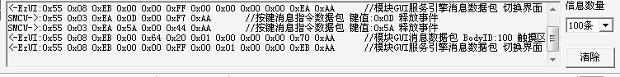
In the information display column on the left, the data in the data packet is displayed in hexadecimal and the analysis results of the data packet are displayed; and the lead of each line of information identifies whether the data packet is sent by EzUI module or user MCU:
- "<-EzUI": indicates that the data packet is sent from the GUI service engine of the EzUI module, including the EzUI module using the tool software module, or the EzUI module connected to the computer through the serial cable;
- "SMCU->": indicates that the data packet is from the user operation area of EzUI_Simulate tool, simulating the command data issued by the user MCU;
- "MCU->": It indicates that the MCU of the user connected to the computer through the serial port is sent when the tool is in software simulation mode.
On the right, you can set the number of data packets that can be saved in the observation column, and you can also clear the current display data.
Note: In the communication data observation column, the more rows of information displayed will cause the display of the tool to slow down. Therefore, users can adjust the appropriate amount of information according to the actual situation and requirements.

Debugging in software simulation mode
The EzUI_Simulate tool, in software simulation mode, is equivalent to simulating an EzUI module on a computer. Users can see the same display interface as the EzUI module within the display area of the tool software. If the opened resource file supports touch screens, users can use the mouse to simulate screen touch effects in the display area. If the user connects the microcontroller to the computer via a serial port and opens the corresponding serial port in the tool software, the user's microcontroller can send command data packets to the tool software, which will then simulate the execution of relevant operations by the EzUI module.

Interface debugging in software simulation mode
After opening the EzUI_Simulate tool, it is in software simulation mode by default. At this time, the corresponding resource file can be opened in the tool to simulate the corresponding display module. As shown in the figure below, a 4.3-inch module resource file with touch function is opened:
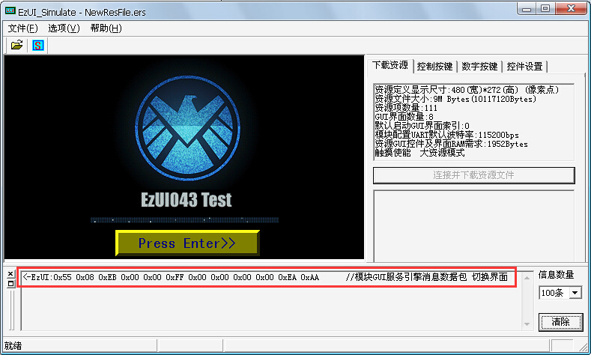
Click the button in the toolbar to open the communication data observation column. As shown in the figure above, you can see that the newly opened resource file is equivalent to the EzUI module starting to work after being powered on. The EzUI module GUI service engine will return a data packet, as shown in the red box above.
Click the "Press Enter>>" button in the display area with the left mouse button, as shown in the following figure before releasing the mouse:
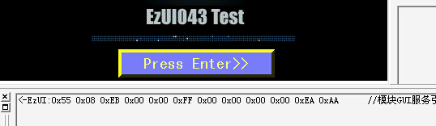
After the left mouse button is released, it is equivalent to the button has a press release event. Then the tool software will perform actions according to the control configuration and related control messages in the resource file. In this example, the button has added control messages, which will switch the display interface as shown in the following figure:
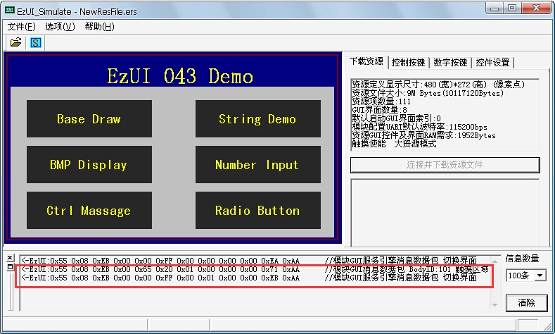
The red box in the figure above is an event message generated by the GUI service engine after pressing the button control.

User MCU participates in simulation debugging
In addition to the operation described in the document, the user needs to prepare the MCU (microcontroller) and connect the MCU's UART interface to the serial port of the computer through the serial cable; in this example, the MCU will send a string display instruction packet to the computer via the serial port.
Before operation, it is necessary to configure the EzUI_Simulate tool software. Click "Options" in the main menu and select "Serial port configuration" in the drop-down menu item, as shown on the left of the figure below. The right side is the dialog box opened after selecting this menu:
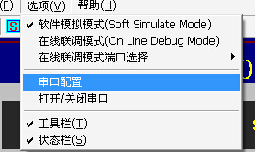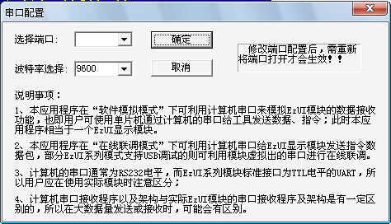
Select the corresponding port number in the dialog box, set the baud rate that matches the MCU used, and finally click "OK".
After the serial port and baud rate are configured, you need to open the serial port and select the menu "Options" ——> "Open/Close Serial Port". If the serial port is successfully opened, the status of the current open serial port can be displayed in the status bar below the tool:
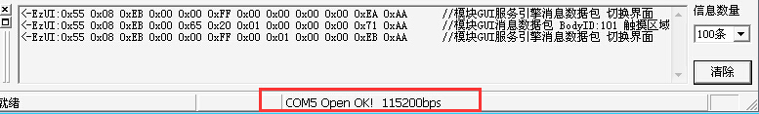
Then the MCU sends a data packet. In this example, the string display instruction will be sent. The content of the string is "MzDesign", and the following effect can be seen:
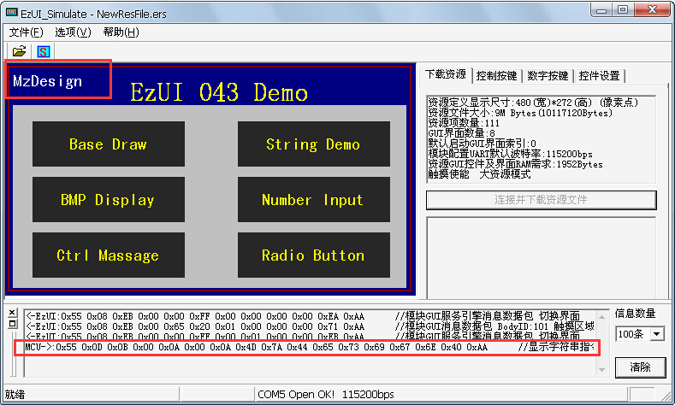
Of course, in addition to this instruction, the user can also send more instructions supported by the EZUI module through the MCU, and the MCU can also receive the GUI service engine return message packets sent by the EZUI module simulated by the tool software.

matters need attention
When using EzUI_Simulate tool for software simulation, the serial port baud rate set in the tool software has nothing to do with the definition in the resource file to be loaded by the actual module. The setting during debugging in the tool only needs to match the setting of the user MCU at that time.
The standard modules of EzUI module are mostly TTL early UART interface, while the serial port of the computer is RS232 level interface, which need to be connected through level conversion.
The EzUI_Simulate tool cannot simulate the low power mode of the EzUI module, nor can it simulate the backlight setting of the EzUI module. In fact, when the backlight value is set too low, the EzUI module may not be able to see the display content.

Online joint debugging mode (USB port joint debugging)
Online Debugging Mode (USB Port Debugging): This mode supports only the modules in the EzUI series that have USB debugging capabilities. Modules with USB debugging support will create a virtual serial port on the computer. Users need to open this serial port in the tool software, then use the tool software to burn the opened resource files into the module and synchronize debugging with the module. For parts of the EzUI module that do not support touch, the tool can simulate some key messages sent by the user's MCU.
Next, we will take the EzUILet024 module as an example to introduce the use of the tool software in this mode.

Install the USB driver
If the EzUI series module with USB port debugging function is connected to the computer for the first time, the user will be prompted to install the driver. The connection line requires the MiniUSB port at the module end. Before connecting, please confirm that there is no other connection at the module, as shown in the following figure:
Note: For the EzUI series of large resource modules, such as EzUI070, EzUI035, EzUI043, etc., when the dial switch on the module is switched to the normal working mode, the USB port should be connected to prompt the installation of the USB driver.
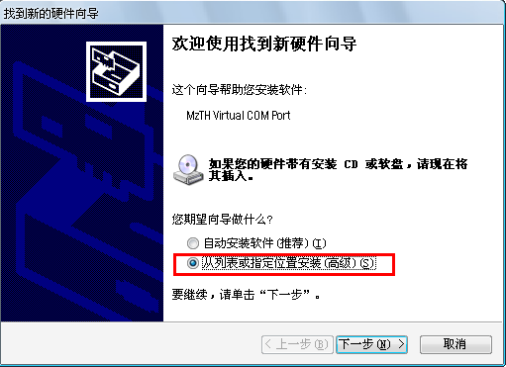
Select the location to install the driver and click Next, as shown in the following figure:
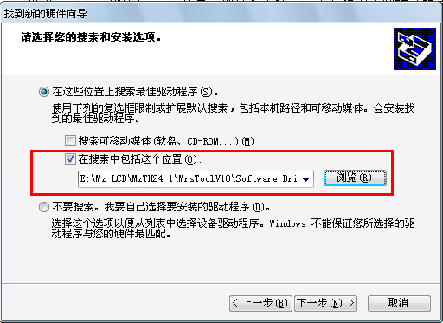
Click "Browse" in the red box above to open the path selection dialog and point the path to the driver folder, as shown below:
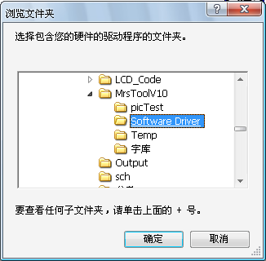
Click OK to return, then click Next to enter the driver installation interface, but you may see this prompt:
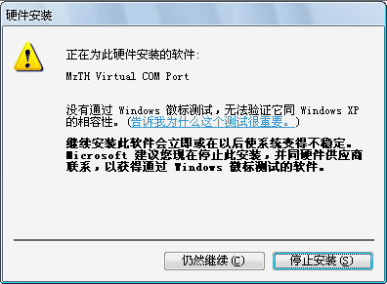
After selecting "Continue", the installation of the driver is completed.
Note: In the above example, the path of the driver file provided may be different from the actual one. Users are requested to search for USB drivers in the folder of EzUI_Simulate tool.
After the driver is installed, the user needs to determine the port number of the serial port virtualized by the computer, as shown in the following figure:
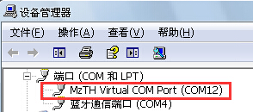

Debugging without opening the module port
The EzUI_Simulate tool can also be debugged before the module is opened and connected to the serial port virtualized by the computer.
After opening the EzUI_Simulate tool, select "Options" ——> "Online joint debugging mode" in the menu, and then confirm that the option of "Module USB synchronous joint debugging mode" is selected in the pop-up menu of "Online joint debugging mode port selection", as shown in the following figure:
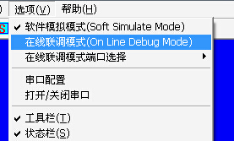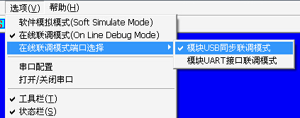
Then, click the tool button in the toolbar to open the "Communication Data Observation Bar". Through the dialog box of opening the file, an already generated resource file is opened. At this time, the tool software displays as follows:
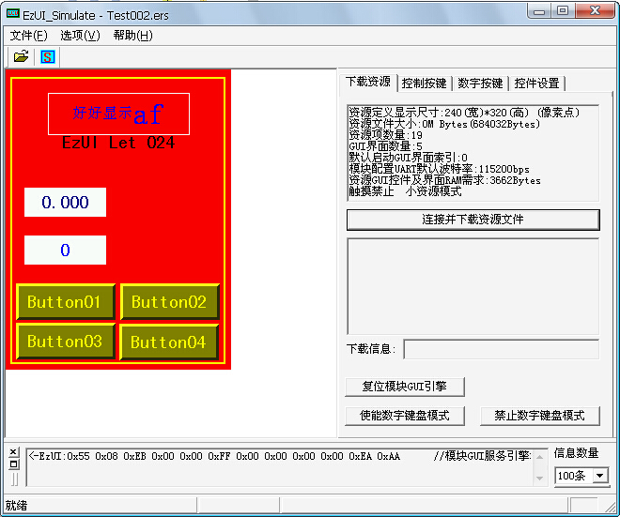
As can be seen in the figure above, some buttons in the "User Operation Area" are already available and will serve as function buttons for simulating user MCU to send commands to the EzUI module.
Switch the TAB of "User Operation Area" to "Control Key", as shown in the following figure:
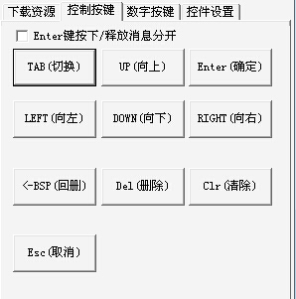
When you press the TAB (switch) button, you can see the following display effect in the display area:
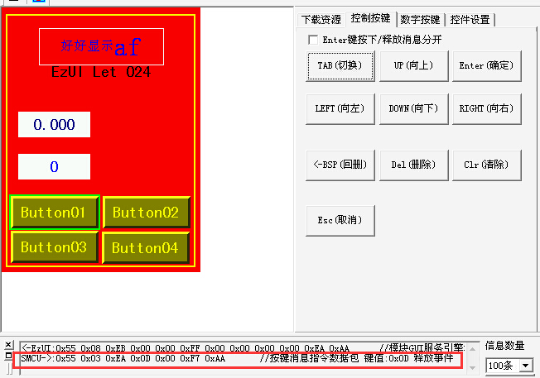
In the figure above, the key message data packet sent by the simulated user MCU issued by the tool software can be seen in the communication data observation column. At this time, the edge of the "Button01" control in the display area is displayed in reverse, indicating that the control is selected.
At this time, pressing the "Enter OK" button is equivalent to the user MCU sending a key message of the OK button. The controls in the display area will have a display response effect, as shown in the following figure:
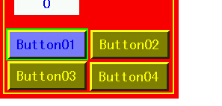
Then the "Button01" button control releases and restores the display effect of the selected state. At this time, a control message for switching interface display has been configured for the control in the resource file, which will drive the GUI service engine to switch the interface, as shown in the following figure:
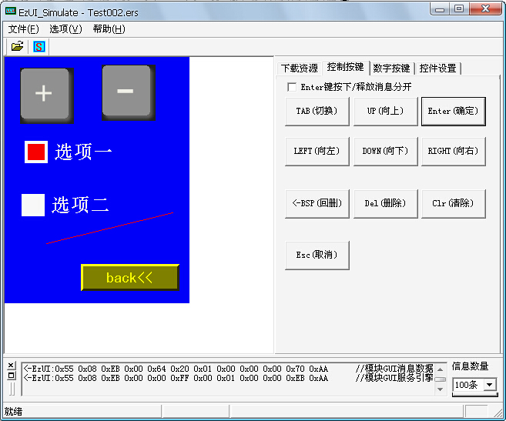
In the new interface, since no control has been selected before, it can be seen that none of the controls in the display area are in the selected state. Then, press the "TAB (Switch)" button, select the "back<<" button, and press the "Enter Confirm" button to trigger the release event of this button. The resource file has already configured a control message for switching interfaces for this control, which will drive the GUI service engine to return to the previous interface, as shown in the following figure:
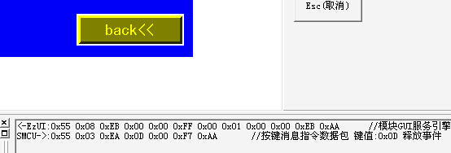

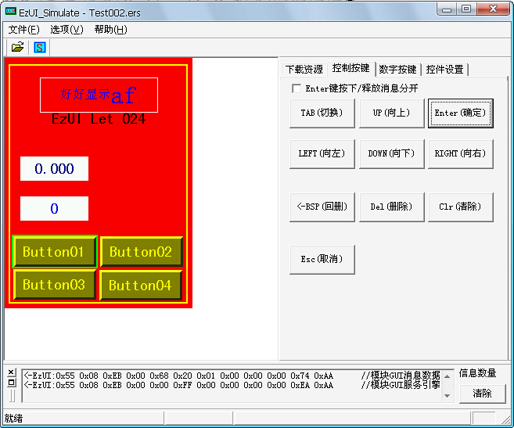
At this point, press the "TAB (switch)" button continuously to make the value control in the interface in the selected state, as shown in the following picture:
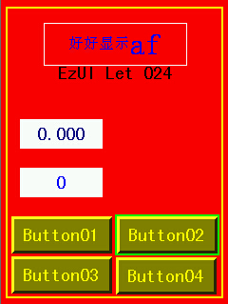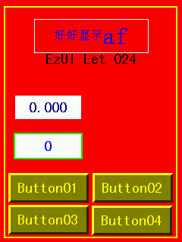
At this point, press the "Enter to confirm" button again to enter the setting of the numerical control, as shown in the following figure:

The numerical control shown in the figure has a blue block at the '0' data position that actually flashes, indicating that value editing is currently taking place at this position. This flashing block is referred to as the current edit position indicator cursor. At this point, pressing the "UP (up)" or "DOWN (down)" button to set the value for this position will result in the following display effects after pressing once, twice, and three times:

After completing the editing input of a certain data bit, the user presses the "LEFT (left)" or "RIGHT (right)" button to switch the editing position. If the value has not exceeded the maximum allowable value of the control and the current editing position is at the far left or far right, an additional data bit will be added when switching the corresponding editing position. Based on previous operations, if the user presses "LEFT (left)" once, the display effect will be as shown in the following figure:
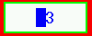
Then press "UP" four times, as shown in the following figure:
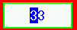
Then press "RIGHT (right)" twice, as shown in the following figure:

Press "DOWN (down)" three more times at this point, as shown in the following figure:

After the numerical input is completed, press the "Enter to confirm" button, the control is completed, exits the setting state, and updates the numerical display content of the current control. As shown in the following figure:
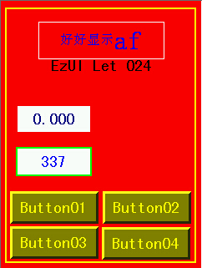

In addition to controlling the display module's controls through operation of tool software and digital buttons to simulate user MCU sending key messages for setting, it is also possible to directly select the corresponding control in the tool software and modify its value/state, then write updates. This is equivalent to simulating the user MCU sending control value/state write commands to the module.
Switch the TAB of "User Operation Area" to "Control Settings", and select the control ID number to be set in the page by using the drop-down selection box. Select the numerical control with ID number 103, as shown in the following figure:
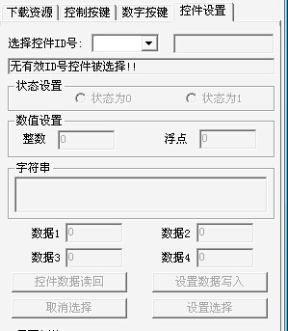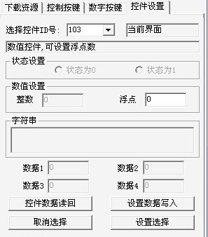
Then, in the floating point input box of the numeric control on the page, enter 3.96 and press "Set data write". At this time, it is displayed as follows:
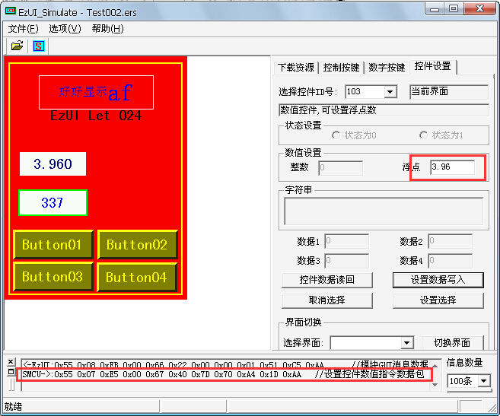
In the figure, the data packet in the red box shows that the tool software simulates a user MCU sending a control value/state write command data packet to the display module. The value to be set is a floating-point number 3.96. In standard C language, a floating-point number is represented by four bytes, which are 0x40,0x7D,0x70, and 0xA4. When combined, they form 0x407D70A4. If the user wants to verify whether this representation is correct, they can assign the above values to the address pointing to the floating-point variable in the programming environment of a microcontroller or another platform, and then check the data of the floating-point variable.
In addition to the above operations, many examples of button operations cannot be presented one by one. Users can use tool software for relevant testing and verification.

Open and connect the module port to download the resource file
On the basis of the previous operation, in this section, the EzUI module needs to be connected to the computer through a USB cable. The EzUI_Simulate tool software will be introduced to burn the resource file into the module.
Take the EzUILet024 module as an example. As mentioned in the previous section, after installing the driver, the EzUILet024 module recognizes a virtual serial port in the computer with the port number COM12 (which may be different from one computer to another).
In the EzUI_Simulate tool, select "Options" ——> "Serial Port Configuration" from the menu. In the opened dialog box, choose COM12 port, and set the baud rate as you wish (the serial port created by the EzUI module does not require a specific baud rate). Finally, confirm the settings. Then, select "Options" ——> "Open/Close Serial Port" from the menu to open the serial port created by the EzUI module.
The status bar of the tool software will show the current serial port opening situation, as shown in the following figure:
At this time, press the "Connect and download resource files" button in the "Download resources" page in the "User operation area", and the EzUI module will enter the resource download mode. The module display interface will show the status of the resource files previously burned into the module, as shown in the following figure:
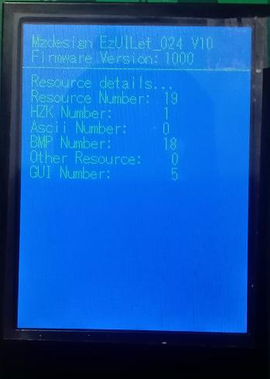
The EzUI_Simulate tool will also obtain the configuration information of the current module from the module and display it, as shown in the following figure:
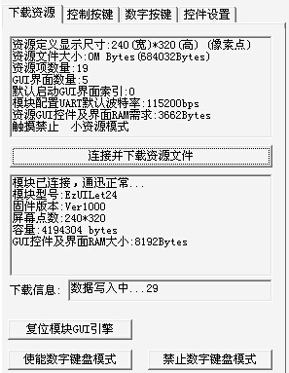
After the resource file is downloaded, the EzUI module will display the information of the download completion, as shown on the left of the figure below, and the corresponding interface of the tool software on the right:
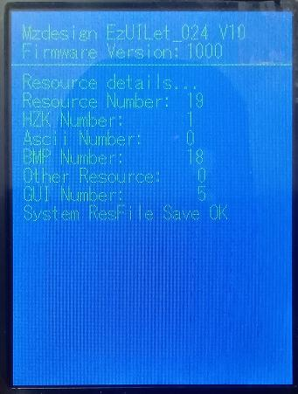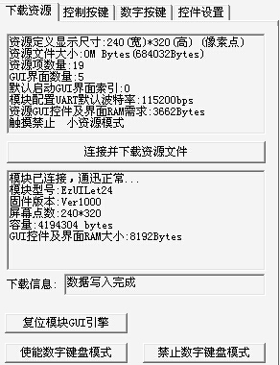
Then, press the "Reset module GUI engine" button, which is equivalent to simulating the user MCU to send a control command to the EzUI module, which can make the EzUI module that supports the command recover to the interface displayed after power on, as shown in the following figure:
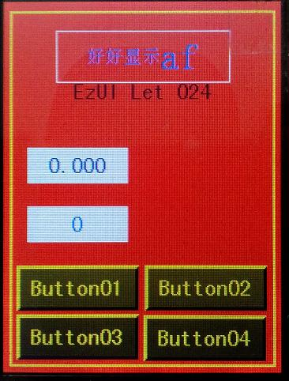
The following figure shows the interface displayed by the tool:
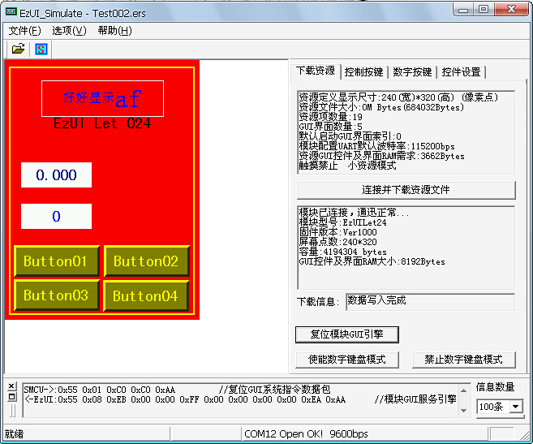

USB port synchronization and debugging
Based on the previous section, the display area in EzUI_Simulate tool will be synchronized and updated with the EzUI module connected to the computer by executing the controls and digital buttons in the "user operation area" introduced earlier, or by writing the value of the control.
The following is a summary of the relevant matters to be noted in the synchronous joint debugging of the USB port:
- The EzUI module must have the USB port joint debugging function;
- The EzUI module is connected to the computer with a USB cable and the driver is installed in advance. The computer can identify the virtual serial port of the module;
- The resource files in the EzUI module are the same as those opened in the EzUI_Simulate tool;
- Set EzUI_Simulate tool to "online joint debugging mode" and select "module USB port joint debugging mode"; configure the serial port according to the actual situation, and finally open the serial port.

Online joint debugging mode (UART interface joint debugging)
Not all EzUI modules have USB port debugging function, so when you want to verify whether the EzUI module works properly or observe what information the GUI service engine performs when the EzUI module is working, you can use the UART interface debugging function.
The user needs to connect the UART interface of the EzUI module to the computer's serial port via a serial cable. Configure the EzUI_Simulate tool software, click on "Options" in the main menu, and select "Serial Port Configuration" from the drop-down menu. Choose the appropriate port number in the dialog box and set the baud rate that matches the EzUI module being used. Finally, click "OK".
After the serial port and baud rate are configured, the serial port needs to be opened. EzUI_Simulate also needs to open the same resource file saved in the module.
After all is ready, if the EzUI module is a touch-enabled module, you can perform touch operations in the EzUI module. At this time, the EzUI_Simulate tool will synchronize with the display on the EzUI module (except for the pop-up input window).
For the touchless EzUI module, users can operate some controls and digital buttons in the "user operation area" of the EzUI_Simulate tool to simulate the user MCU sending key messages to the EzUI module.
In the "Communication Data Observation Bar" of the tool software, you can view the data packets sent by the UART interface of the EzUI module.

matters need attention
- When using EzUI_Simulate tool for online debugging of module UART interface, the serial port baud rate set in the tool software is consistent with the definition in the resource file to be loaded by the actual module.
- The standard modules of EzUI module are mostly TTL early UART interface, while the serial port of the computer is RS232 level interface, which need to be connected through level conversion.
- The EzUI_Simulate tool cannot simulate the low power mode of the EzUI module, nor can it simulate the backlight setting of the EzUI module. In fact, when the backlight value of the EzUI module is set too low, the display content may not be visible

technical support
Mingzheng Tongchuang has extensive experience in LCD display drivers and has summarized a mature, universal LCD driver architecture through accumulation. This architecture can be easily ported to different LCD applications or different MCU application platforms. With the launch of new products, more complete drivers will be introduced. Users of these codes or application development software can use them with confidence in their products.
In terms of human-computer interface programming, Mingzheng Tongchuang will also provide users with more references, or customize special designs for users, so that users of Mingzheng Tongchuang can not only get high-quality and inexpensive products, but also obtain professional technical support.
The goal of Mingzheng Tongchuang is to be a professional provider of products + technology in the industry.

contact way
Hotdisplay Technology Co.Ltd
Contact number: 0769-87298923 (Sales/Technology)
Service email: lcd@hotlcd.com

